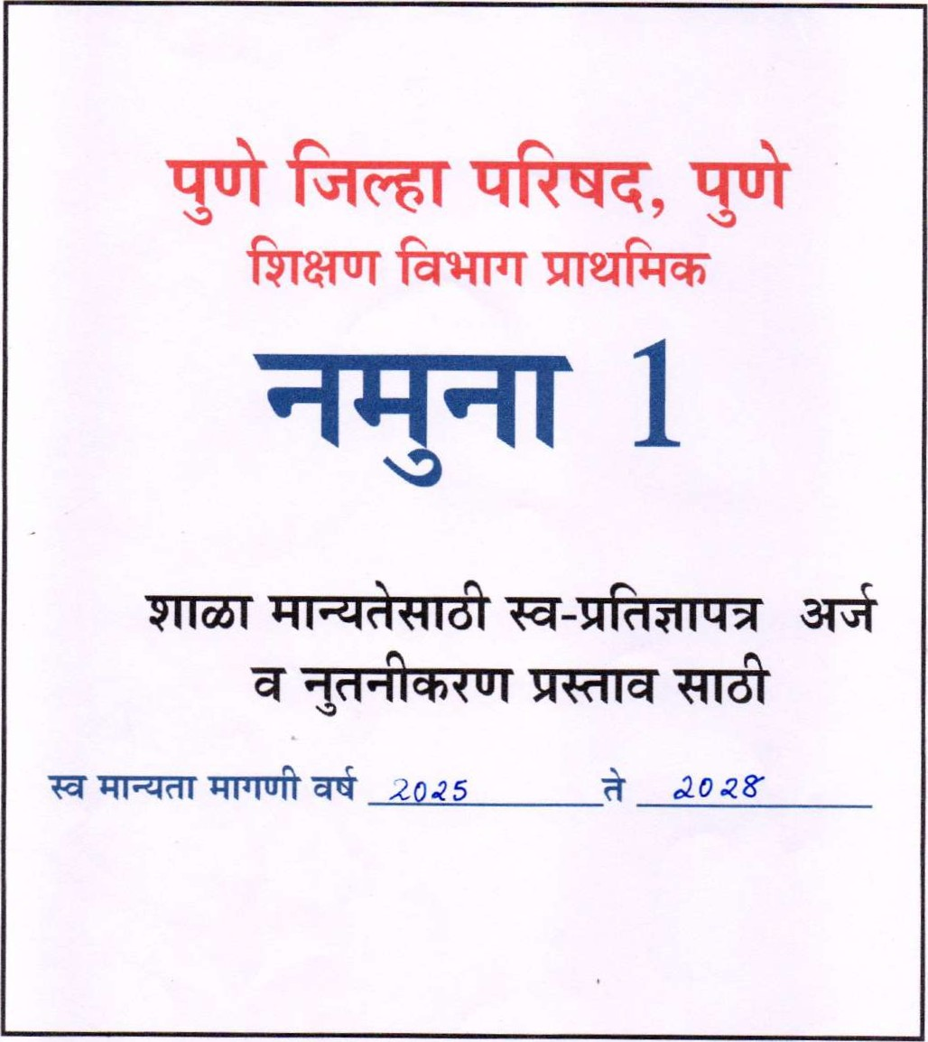

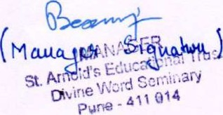
Principal
Arnold's Schccl
-
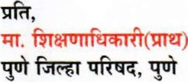
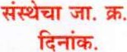

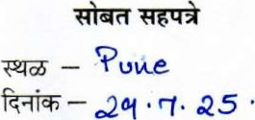
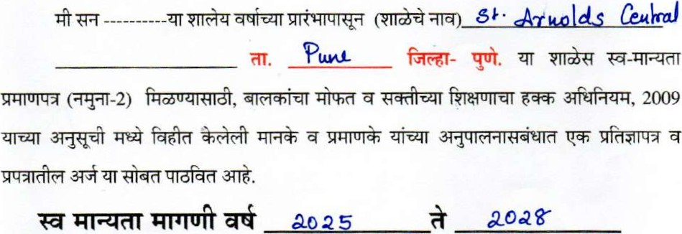 scuool

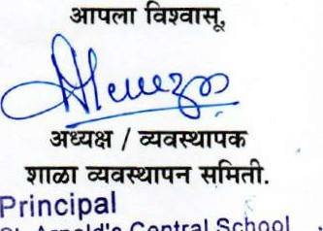
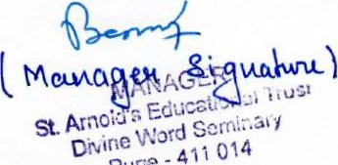
Principal
School
Central
St. Arnold's
Near Sun City, Wadgaonsheri, pure Pune -411014
 | qfra0r.
1.
2. | 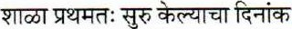 |  | A 00 G
3.
4. | 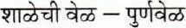
5. |  | 00 | IQ
6. |  |  | h' 1 5 noou
7. | 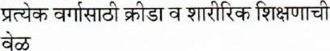 | 810 | q • 00 QAĄ
8. |  | Sb | td-ucaHotĄa.l  ¯rvud•-
 |  | 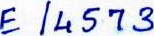
 | (Ț) 1860
 | 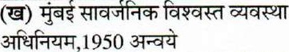
10 | 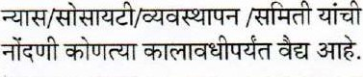
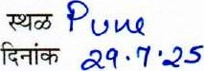
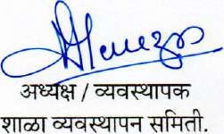
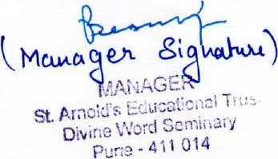
Principal Arnoiďs
1

 | 
1. |  | 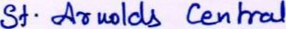 School
2. | UDISE Code | ISO 12 13
 | 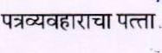 | 3VD C.ÆNPDS , NEAR  NJADQORNSHERI, PONE kitOlk.
4. |  | P UNE
5.
 |  | PUN E
7. |  | Allow
8. | 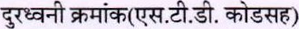 | o ao- aqqq6A6k
9. |  | Cc-Gol •
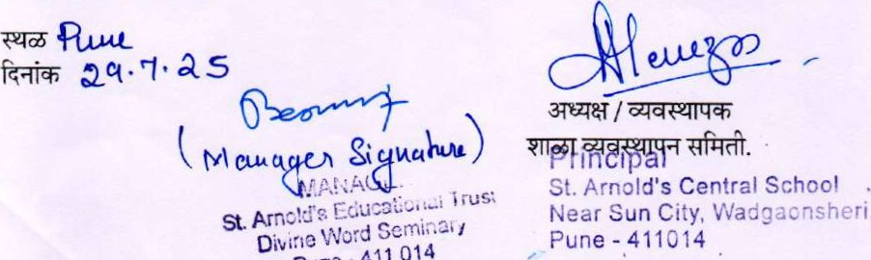
Wadgacnsheri,
11 | 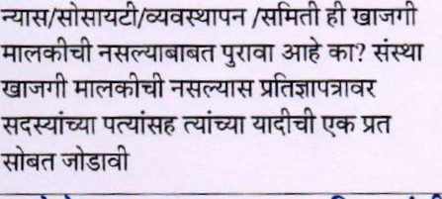
12
(1) |  |  |  | (2) |  | (3) |  |  | (4)
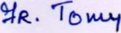 |  |  |  | RESIDENT |  | g VD CARPUS  'J Aoqa0NSHERl
 |  |  |  |  |  | 1 1
⁰4K. %TESVRAS |  |  |  | MANAGER
13
 |  |  |  |  |  |  |  |  | 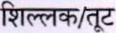
1 |  | 2 |  |  | 3 |  |  |  | 4
 |  | q , 90. 3+801 |  |  | 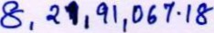 |  |  |  | 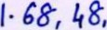 733.
023- Ak |  | 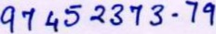 |  |  | 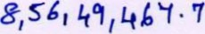 |  |  |  | 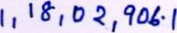
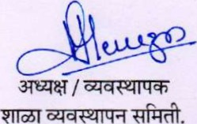
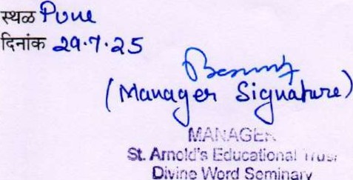
Principal
Word
Scrninaay
Arnold's .
Pune -
 | 
1 |  | ENQASH
2 |  | CO - EDUCATI ON
3 | 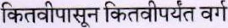3TT&T.
4 | 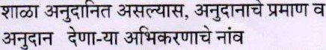
5 |  | NES
6 | 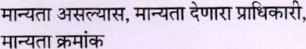 | No -n 30kG3
7 | 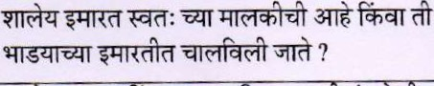 | RENTED
8 | 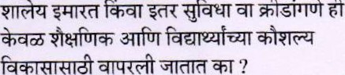
9 |  | 23600
10 |  | 8 430 • 1 7
11
12 | 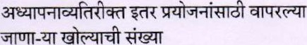
13 |  | 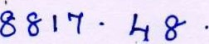
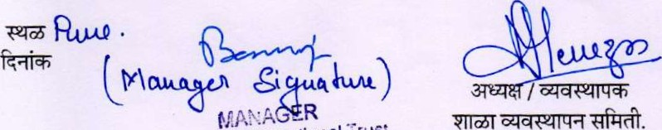
St. Arnc%'R Educational trust | Principal
Diulno Vs'ord Seminary puno - 411 014 | St. Arnold's  Near Sun City,

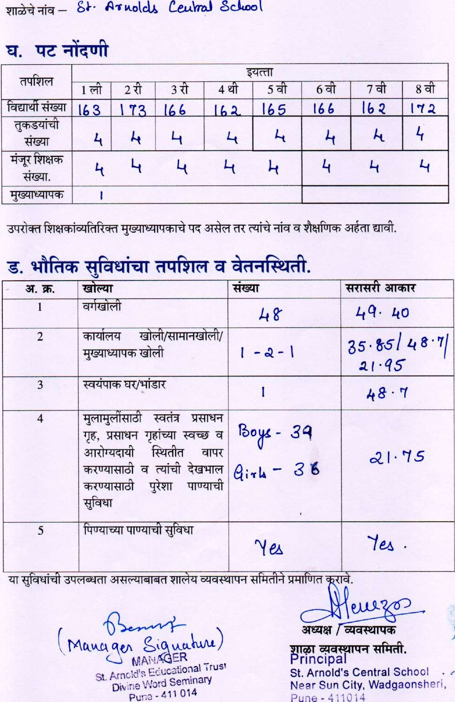
Cezdr•mJ
School
11, 2011/31TfQFT19, 1933
 | 
1 | 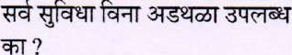
2 | 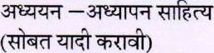 | N A
3 | 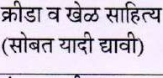
4 | 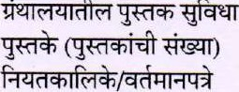
5 | 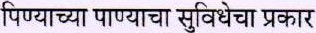 | Coolvt
6 |  | Qoo cl
 | 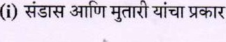 | 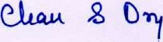
 | 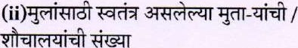 | 89
 | 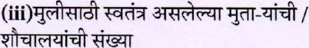
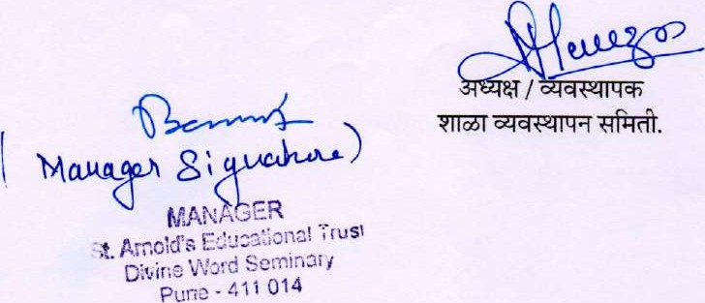

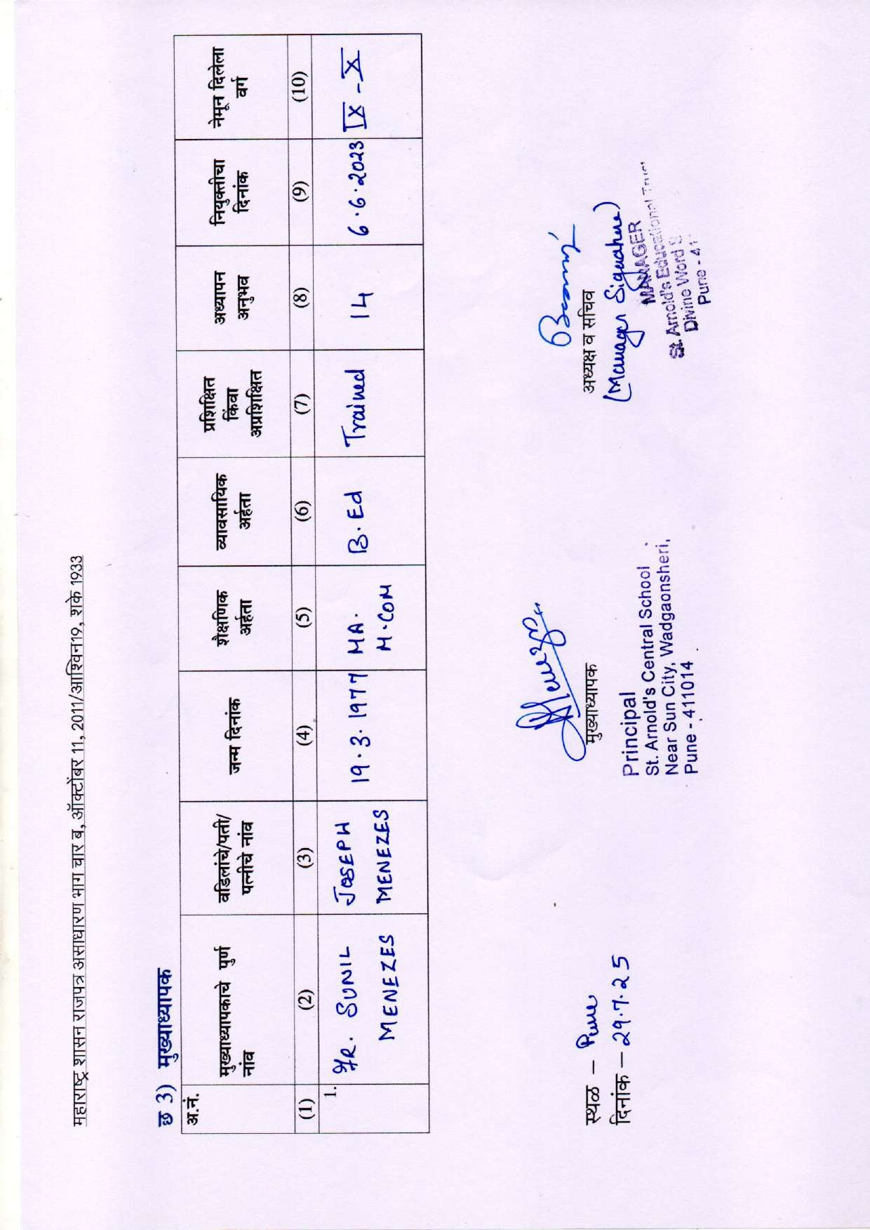

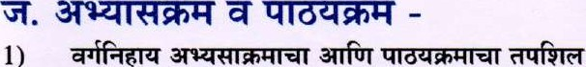 ( V. 8 år q&T)
1)
a.TTfrr
1 | 
2
3
4
5
6
7
8

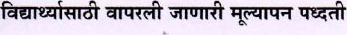
2)— FoRNATIVE CANO SUMMATIVE
Ass ESSHe
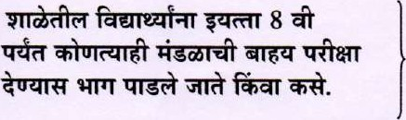
3)
St. Arac!d'G Educational Trust | Principal
Word Seminary | St. Arnold's Central School
Pure -411 014 | Near Sun City, Wadg•sheri  Pune -411014
No

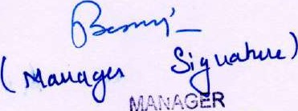 PTTJT 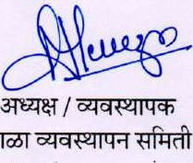

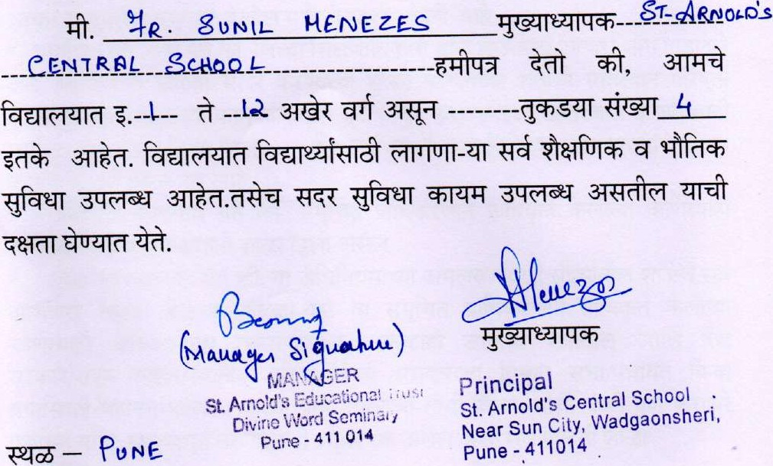
247. a 5
ST • ARNOLßs CENTRAL gcH00L
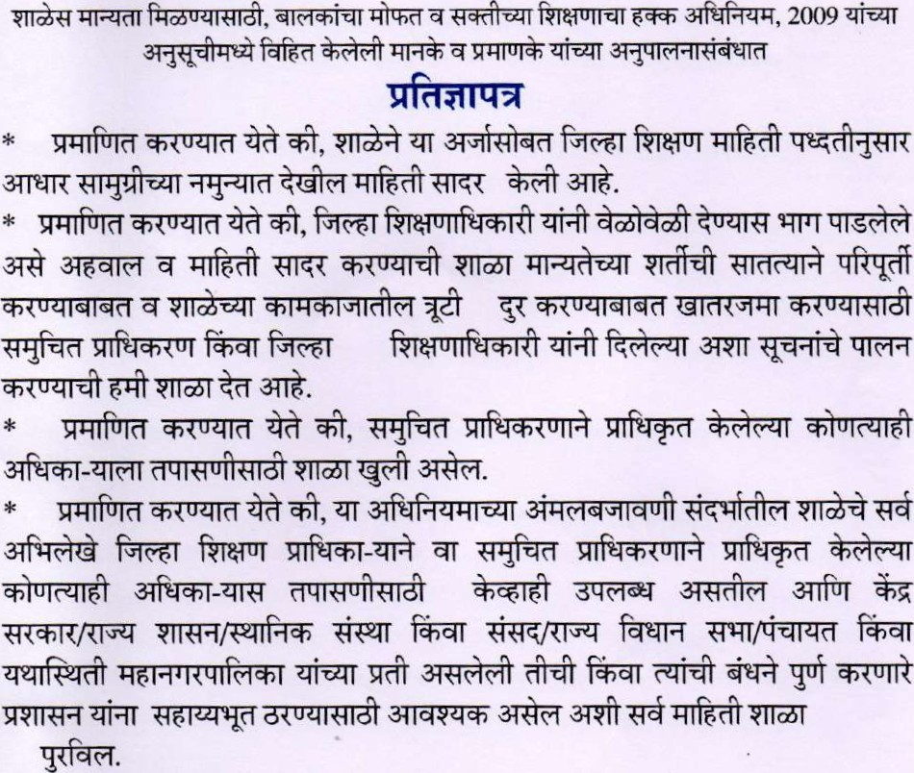
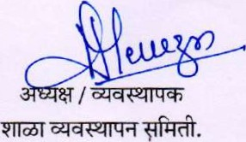
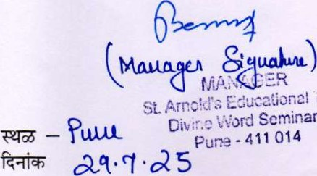
Principal
i
tus,
Seminary
St. Arnold's Central School
Near Sun City, Wadgaonsheri,
Pune-411014
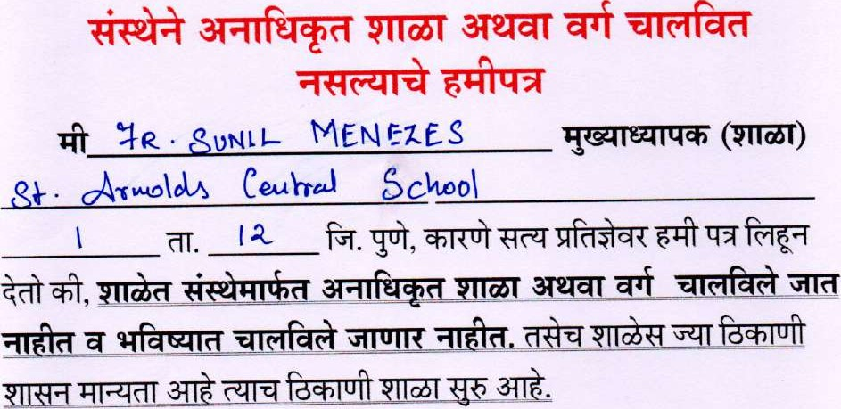
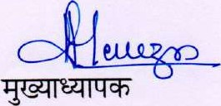

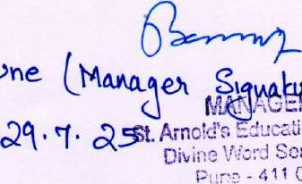
rincipal
—ducaüona!
St. Arnold's Central School
— Pone hp-e) Pune -411014Near Sun City, Wadgaonsheri,
— Seminary
014
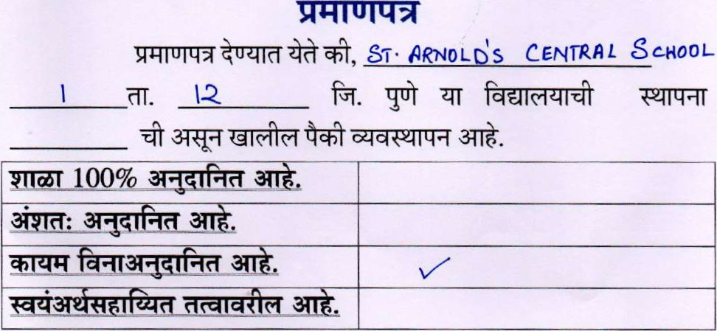

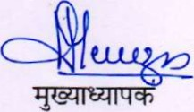
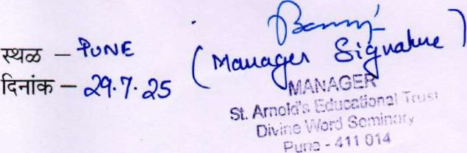
Principal
St. Arnold's Central School
Near Sun City, Wadgaonsheri,
Pune - 411014
vrràà
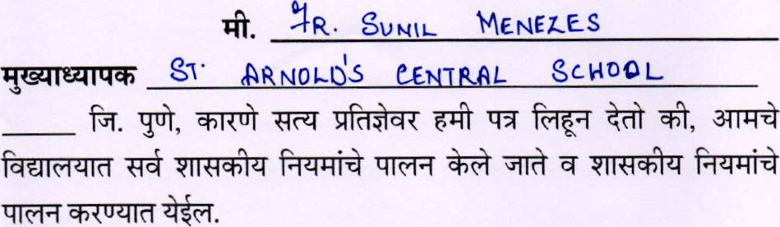


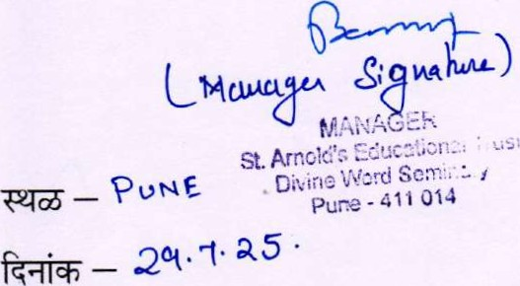
principal
St. Arnold's Central School
Near Sun City, Wadgaonsheri,
Pune - 411014

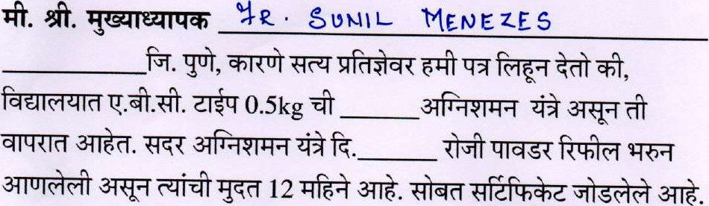
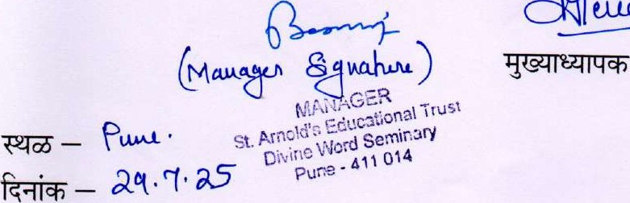u-LL26Y?

EAR-NOLA—CENTRAL
CCHOOL

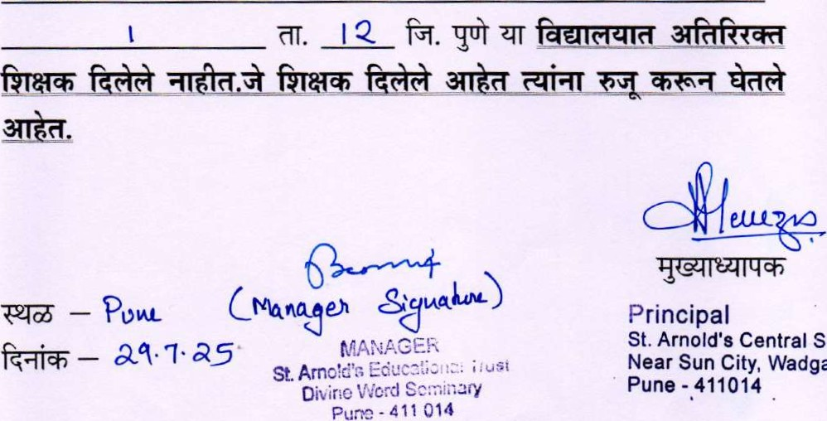
Principal
St. Arnold's Central School
aq.q•as Near Sun City, Wadgaonshe
Pune - 411014
Б. 0eta1B 01 Staf
6.1 lnformation of t.h• етр4оу•в РНтагу Иррег of each teacher to be filled in sepatatel%•.)
Fpj от Мате Ttaitied 0f
1 | 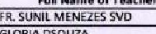 | 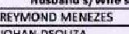 | 19-03-1977 |  |  | 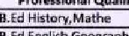 |  |  | ос | Тех | O•te оь-оь-аав | 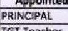
З  4 | АМТНААТУАШХЖ МАНА | OSOUZA  ARUN доге ALLOOR | 29-08-1985  29-05-1980 | В.А,МФ  3.sc |  | Engligh ВеодгарАту  В, Marhem•tcs  Вл |  |  | tr•heWTGt | 11  10 | 06-04-xns  06-04-2015 | 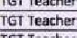  ТВТ
s  S | омрадкк;н янсн ипр•ис.А nsol_n MEtl_AM | омракњн  osouu | 09-12-1976  29-01-1914  15.07-1975 | ВЗс,М А |  | Ed 5ceioce aod Ma!hs  Sotial StuB  Н, |  |  | 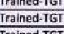 | 14  19 | 009.iOi3  09-04-201 S | 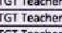  ТбТ
8 | EJASWlM  ЕЯК]Т FRAMC'S АНАТ | 5АМЕЕЯ  FRANC15 дгнат | С2-ОЕ.19Љ | в.свт.м„д Н5с„В.А |  | 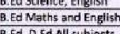 |  |  | ТгэГпее.Т5Т | 13 | 01-06-2013  ПЕ-оь-зоп | 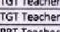
д | SAHOOF  SHOBHA SANE | SOVOMON  АНЖ SALVE |  | НДМ.А В.А,М.А |  | В. Ed Hi5twy,EMi5tT |  |  | гга[леа-ТЗГ Тгз[лев-ТЗТ | 13  20 | 01-0,6-2009 | 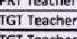  TGT
 | К.ЦРАНА SjN*GH  ИТТДМ PAWAR | Анк S'NGH  JAMZS РАТОЦЕ | 10-11-1980  22-05, 1991 |  |  | S-tiQfvtQ , math±  В. |  |  | hed-TGT |  | 10-04-2015  1S-06QQiS | ТЪТ  ТЪТ Теае,ет
В  14 | знаял ЈАНЈАМЕ% |  | 20-09-1982 | В сол.МА |  | 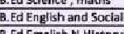  50da15 |  |  | ТВћеВ-ТбТ | ш | 06-064011 | ТбТ ТеагЬет  ТбТ
16 | рил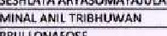 | Т3ВНјУ.јдр.4  WNAFOSE | 33-094992 | Сот,МА  e.sc |  | 3.[d Sciente |  |  | ТгаЛпеВ.Т6Г | [0  [1 | 01-08*015  04-06-2014 | ТбТ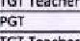
 | ВНА'.ЧАЬИ SHAH | *АЈЛ.' ЗНАН. | 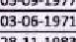 |  |  | 3_Ed Sdence amd Maths |  |  | ГраЗпеВ.ТбТ |  | 07-04-2015 | ТвТ
18 та | 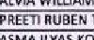  V50J2A пизеры ГАМВЕ  АМА  XOTWAL | дугџивм 05СЏ(Я  ТАМВЁ | 2203-2980 | М.А  в.д |  | 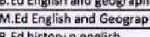  Geegf.ph, |  |  | газ зеВ.т-зт trehed.T6T | 15 | 3D-04QW8  30-04-2010 | ТЪТ
21 | 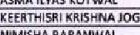  м.ме;нд |  | 02-074973 |  |  | 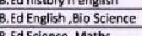  3,Ed |  |  | 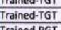 |  | 01-06-2010 | ТЪТ ТеасАет ГОТ
В | ЮАН“ РТЕЕКАН ГНКТЕ  SREEkANIF-f | *ШКИМДВ 3ARANWAl lPT€€kAR СН!КТЕ не€кдмтн | 16-09-1981  24-01-1985 | 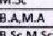 |  | 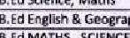мДтнЗ ,  GeoerapBy |  |  | 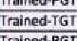 | 9 | 0806,2016 | PGT te•ehet  ТЪТ зЗТ
25 | *ЕМА злетн€юд нИМ HAtNASHtkHAR РА\ОIТ  ВОЛ | 5НАЩЕ5Н  НАГЖЊНЕКНМ  ЗњНТ | 24-05-1976 | В.%.МА  В.%.М.Ж'МВ.А  Д.Сот,м.А |  | в. ЕВ SciEate, EfOsh  3.€3 Math± HiBdi |  |  | 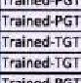 |  | опе-дпз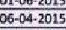 | 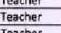  та;т рът  TGT
29 | AFSHA SAYYED | 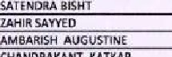 | 010-iGIS  03-08-1985  -Т988 |  |  | Н. Ed Enkli5h & 6eoxrapt1  В, беовгзрету |  |  | 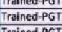 | В | 06-06-2006  06462012 | Теаећет  PGT  PGt теасћее
31 | Р ЯАСН' сне.еыпакдчт КДТКА*  С[АЯ€ EDGARSQU€lRA | 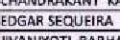КАТИА | 15-074983 | 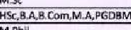 |  | 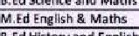Sc;etxe atid  З. |  |  | 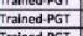 | 13 | 01-06-2012 | PGT г  РбТ теаге:рг
33 | деди  М'ОН. | 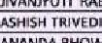изнд | 12-01-1982 | МА |  | 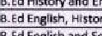  B,EdHi |  |  | 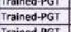 |  | 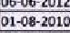 | РбТ Теае-.ег
34  3S | АТЈЫМД EHOWMiCk мДТ• | 3HQWMLR  КДИ\ТДНН НЕНА | is.Oi.i9B1  10-0i-L9iO | мад  M.sc |  | 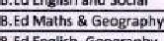  Etrg'ish |  |  | 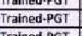 | 11 | 01-08-гла ог-и-ьилз от-оыати | 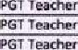
35 | 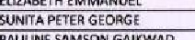  ЕИЕАВЕТН | PRASHA"T  GEORGE | 02-08-1987  10-02•1974 | всл,МСА  ВА |  | 8.Ed EnzHsh, Ceograpt•i  в, & HiSt0 |  |  | Trair,ed.TGT | 23 | 0[.01-2001 | РЕ Т Т евсћег  ТЕТ ег
39 | PAUUNE GAIkWAD РАВ'.'ЕЕМ КНАЕ | :swsop.' GAlkV.TD |  | 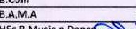 |  |  |  |  | теаеев.вят | 29 | 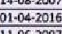 | РИ Teaehet  Teachev
40  41 | МКШКТА ВМЕТЕЕ tOMALASH НЯЈТАЯ | А5Н15Н 5VTAR | ГБФ!.Г97П  0012-1976 |  |  | 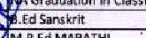 |  |  | 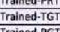 | 19  10 | ат -04-гатз | Оап=е Veacher TGT Те
43 | чаонмтн СННАВАЕ  0€NMSDlAS |  | 09-10-1980 | В. Сот |  |  | hys4c.al €dutat' |  |  | 17  10 |  | Phvs]ca1
St. Arnold's еп
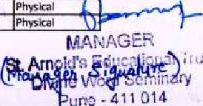
Near Sun City, Wadgaonsheri, рџпе -411014
44 *AWAR UTTÄM PAWAR gcs
as | 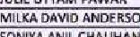  ANDFRSON | DAV'O ANDERSON AN 'L C HAUHÅN | 010-1983 | B.A,MÄ | , Hind/ | 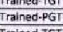  rained | 9  11  12 | 0606 *016  0606-2016  07-11-201A |  | librarian
47  48 | 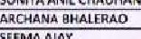 | G\RSP g HALERAO ANTONY |  | 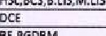 | B.Ed B. Ed Math Science | Untrained r rained. PAT |  | 0*.04-2014 |  | An Teacher
49  50 | SALIMA PARVEZ NILGIRWALA MEERAKSHI CHALjDHARY | 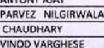 | 08-12-1377 | 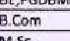 | B.Ed B.Ed |  | 13 | 04-07-201? |  | I S T Teacher  Teacher
 | JEENA  'UUETSELVAN | SELVAN | 20-06-1979 | HSe,A-A | B _Ed Scie n Math  B -Ed ,O-Ed E fish, Math5Scien | 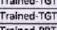 | 8  7 | 05-06-2017 |  | PRI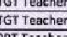
 | BHUYAN BAISHYA  ANCY | BHUYAN JA'SHYA  DAVIS MANOJ | 18-06-1986 |  | B.Ed  M.Ed History | Tlöift2d.TGT | 9 | 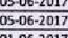 |  | 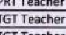
54  SS 56 | 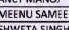SAWER SALATHIA  SHWETA | SAMEEH SALATHA  VXA5 K SINGH | 19-11-1983  ICA2-1979 | M.A | B.Ed  Hindi and Economics | rrauned-TST | 13  12 | 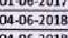 |  | TGTTe•cher
 | NATAUA ISAAC  VUESH KUMAR | RAJESH KUMAR | 14-11-1994 | HSqesceM.sc HSt,BCOrn | ishand Science | Trained-PGT | 6 | 1908-2019 |  | PCI Teacher
S9 | SHAA*A CHAUNAN | RANGASV.'AMV | 28-09-1977 |  | B Economics | 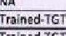 | 11 | 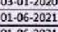 |  | IGT TEACHER
50  51  62 | 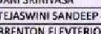  *HARAT  VAN  ARÉNTON  ANTAO | 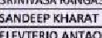  ELEVTERIC | 2+09-1976 | a.Carn.M.Com | E.Ed Hindi Marathi | 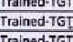 | 4  17  17 | 0106-2021  0106-2021 |  | TEACHER  TGI TEACHER  PGTTéACHER
 | MATHEW KORATTIYIL  SANTOSH | KORAI'TIVIL  MADAN SHINDE | 1406-1978 |  | a.EdPh Sits | 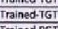 |  | 01-08-2017 |  | Lab Assistant
SS 66 | KANAK PAFUJA | PETER GEORGE GAURAV | 2404-1986  07-04-1999 | 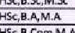 | g.Ed English, Geography  g.Ed English and Maths | r,ained.PCT | 12 | 0104-2022  0104-2022 |  | FGT Teacher PR T Teacher  Teacher
67 |  | *RUTHVJRAJ DHULf  THAKARE | 28-11-1984 | HSc.a.A | D. Ed Hindi  3.Ed MathS | Trained-PG | 10 | 01.0.4-2022 01-06-2021 |  | PAT Teacher
69 | 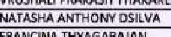  THYAGAANAN | THYAGARAJAN URAON | 2+0?-zcoo | HSerg_AM.A | i Ed Hindi and SST M.Ed | T | 9 o 9 | 0106-2022 otoa-2022 |  | PGT Teacher reacher
 | 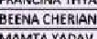  YADAV |  | 19-08-1983 | B.Sc  HSS,3AM.A | 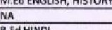 | Trained-TGI |  | 0106-2023  03-10-2023
n | TORAL DUVANI  FR_ JOSEPH 6 | GEORGE JOSEPH | 25-03-1989 | HSc, BF HSG3.Sc | TTC  g. PHSYCIAL | T rained -TGT  T rat" ed.PGt | 23  3 | 01-07-2024 |  | SUPERVISOR
77 | PRISCILLA ASHISH SALVI | GEORGE  ASH'SH SALVI | 19-03-1990  12-03-1991 | HSqB.Com | B. Ed MARATHI | Trained-PRI | 3 | 01-06-2025 |  | IREASURER
79 | CLAIR AMELIA AZAkEOO  ASHWINI 8HARAT GOLELLU | GOLEUU | 16-07-1984 |  | PHYSICAL EDUCATION |  | 3 | 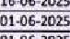 |  | F'RT  PE TEACHER
 | NASA  VRE VILAS TVOMAS PÉGÄDO | 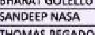 | aa-og-t97E | HSc.B.Com.M.Com  M.sc | MSe Counseli | Trainee PCT | 9 4 g | I-on
01-08-2024 COUNSELLOR

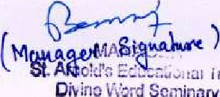frust
Seminary
Pure - 411 Old

